

Melkbosstrand High School
Grade 12 | Computer Applications Technology |  | Term 2  2 June 2026
Time: 3 hours | TASK 3  Practical test |  | Marks: 150
Examiner: F Pretorius |  | Moderator: R. Rabe

INSTRUCTIONS AND INFORMATION

1.  2.  3.  4.  5.  6.  7.  8.  9.  10.  11.  12. | Owing to the nature of this three-hour examination, it is important to note that, even if you complete the examination early, you will NOT be permitted to leave the examination room until all the administrative functions associated with the examination have been finalised. During the examination, normal rules regarding leaving the examination room apply.  Type your Name and Surname in the header of EVERY document that you create or save, where applicable.  The data files can be found in the Exam Data folder on the network or a local computer. If you are working on the network, you must follow the instructions provided by the invigilator.  A copy of the master files will be available from the invigilator. Should there be any problems with a file, you may request another copy from the invigilator.  This question paper consists of SEVEN questions.  Answer ALL the questions.  Ensure that you save each document using the file name given in the question paper. Save your work at regular intervals as a precaution against possible power failures.  Read through each question before answering or solving the problem. Do NOT do more than is required by the question.  At the end of the examination, you should make sure that ALL the files are saved on the network as explained to you by the invigilator/teacher. Make absolutely sure that all files can be read. Do NOT save unnecessary files/folders. Do NOT hand in duplicate answer files/folders.  The separate information sheet which has been provided with this question paper MUST BE COMPLETED AFTER THE THREE-HOUR EXAMINATION SESSION. Hand it to the invigilator at the end of the examination.  During the examination you may consult the offline help functions of the programs that you are using. You may NOT use any other resource material.  Unless instructed otherwise, use formulae and/or functions for ALL calculations in questions involving spreadsheets. Use absolute cell references only where necessary to ensure that formulae are correct when you copy them to other cells in a spreadsheet.

13  14.  15.  16.  17. | NOTE: All formulae and/or functions should be inserted in such a manner that the correct results will still be obtained even if changes are made to the existing data.  If data is derived from a previous question that you could not answer, you should still proceed with the questions that follow.  In all questions involving word processing, the language should be set to English (South Africa). The paper size is assumed to be A4 Portrait, unless instructed otherwise.  Ensure that the regional settings are set to South Africa and date and time settings, number settings and currency settings are set correctly.  The examination folder that you receive with this question paper will contains the files listed below. Ensure that you have all the files before you begin this examination.
20206 Mid-year Exam Data
- 1ICoverPic.png | Image
- 1Digital Marketing | Word processing file
- 2Income Manual | Word processing file
- 3Ads.png | Image
- 3Global Ads Performance | Spreadsheet
- 4eCommerce Customers | Spreadsheet
- 5Capaign Data | Database
- 5Digital.jpg | Image
- 6Index.html | HTML
- 6Plan.png | Image
- Q6_2.html | HTML
- 7Brainwave.png | Image
- 7Marketing Letter | Word processing file
- 7Client List | Spreadsheet


SCENARIO: DIGITAL MARKETING

You are required to develop a basic digital marketing strategy using various digital tools to create awareness, increase visibility, attract customers and improve sales of a particular company.
(Image from: https://surli.cc/icqfki )

QUESTION 1: WORD-PROCESSING
Open the 1Digital Marketing word-processing document.
1.1 | Modify the cover page to display as the screenshot below:    - Image 1CoverPic.png can be found in examination data folder | (4)
1.2 | Insert the text ‘1Digital Marketing' in the Subject property of the document and add a comment to the property of the document that will read: ‘This document is about the origin of digital marketing’. | (2)
1.3 | Modify the 'Strong' style as follows:  - Change the font type to Century Gothic, with text double underlined.  - Change the character spacing to an expanded spacing of 3 pt.  - Apply this to the paragraph under the heading ‘Introduction’. | (4)
1.4 | Add a footnote on the text 'mobile marketing' as follows:  - Add ‘The use of digital technologies and online platforms to promote products or services.’ as the footnote text.  - The reference mark (symbol that appears at the bottom of the page) must be Webdings character code: 85 . | (3)
1.5 | Apply a setting to the document to NOT hyphenate text displayed in capital letters. | (1)
1.6 | Locate the paragraphs under the heading ‘Key Digital Marking Process’ and edit the text to display as the screenshot below:  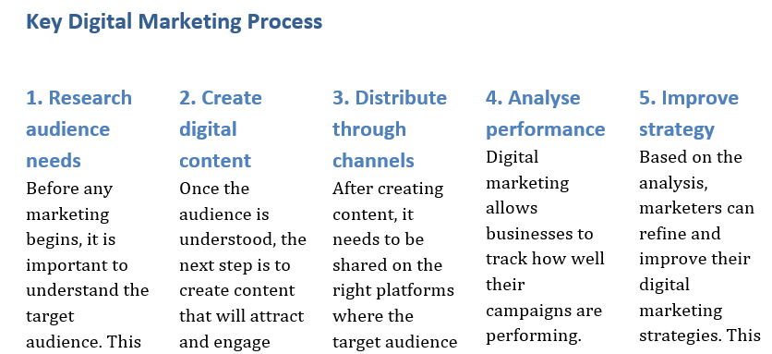  NOTE:  - Apply Heading 2 style to the sub-headings.  - Apply breaks so that all the sub-headings appear at the top of a column.  - Space between columns is 0.5 cm. | (4)

1.7 | Edit the Table 1 on page 5 to display as the screenshot below:  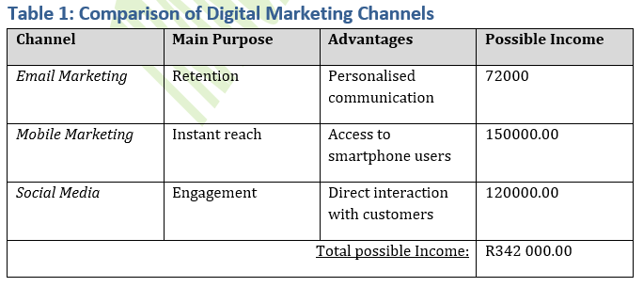  NOTE:  - Apply all formatting as shown.  - Sort the table alphabetically according to the digital marketing channel.  - Add a formula to calculate the total possible income. | (8)
Save and close the 1Digital Marketing word-processing document.
 |  | [25]

QUESTION 2: WORD-PROCESSING
Open the 2Income Manual word-processing document.
2.1 | Apply the following changes to the document layout:
 | 2.1.1 | Apply the ‘Narrow’ margin setting. | (1)
 | 2.1.2 | Change the document size to Letter. | (1)
 | 2.1.3 | Make the following changes to the header section:  - Add your name and surname, left aligned.  - Add the current date on the right-hand side in the format dd/mmm/yyyy. Ensure that the date will automatically update whenever the document is opened. | (5)
2.2 | Apply the Heading 2 style to the text “Do” and “Don’t” under the heading ‘Best Practices: Do’s and Don’ts’. |  | (1)
2.3 | Change the structured lists under the heading ‘Best Practices: Do’s and Don’ts’ to display as shown below:  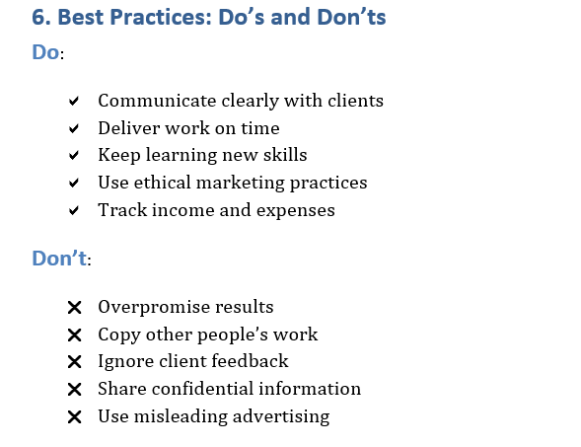  NOTE:  - The symbols used can be found under the font Webdings, character code 97 and 114 respectively. |  | (4)
2.4 | Insert an automatic table of contents (TOC) above the heading ‘Introduction: Digital Marketing as a Career Opportunity’ to display as follow:  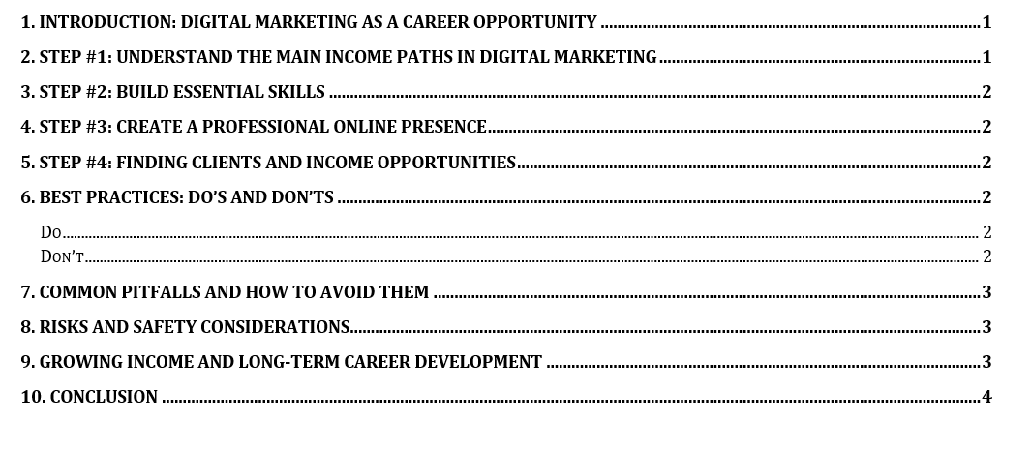 |  | (3)
2.5 | Find the image below the heading '8. Risks and Safety Considerations' and format the picture as follows:  - Crop the image to focus on the main subject (remove unnecessary background).  - Apply an appropriate picture style to the image.  - Set the image to wrap text as ‘Tight’ and position it neatly next to the text.  - Resize the image proportionally so that it fits within the page layout.  - Add a short descriptive label to the image so that screen readers can read it aloud to assist users.  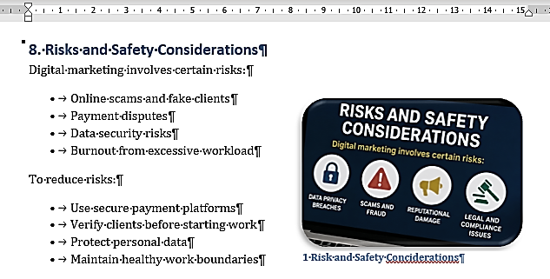 |  | (6)
Save and close the 2Income Manual word-processing document.
 |  |  | [21]

QUESTION 3: SPREADSHEETS
_{NOTE:}
- Use formulae and/or functions for ALL calculations in the spreadsheet.
- Use absolute cell references ONLY where it is required by the question to ensure that formulae are correct when you copy it to other cells in the spreadsheet.
- Insert formulae and/or functions in such a manner that the correct results will still be obtained even if the existing data changes.
- Should you need to use building blocks, use the allocated space in the spreadsheet.

Open the 3Global Ads Performance. The spreadsheet contains data tracking the performance of digital advertising campaigns across platforms like Google, Meta, and TikTok, and consists of two worksheets.
Work in the Global Performance sheet.
3.1 | Apply the following formatting to the sheet:
 | 3.1.1 | Insert the image 3Ads.png in cell A1. | (1)
 | 3.1.2 | Enter the title ‘DIGITAL MARKETING’ in the font Algerian centred across cell range D1:I1 to appear as below:  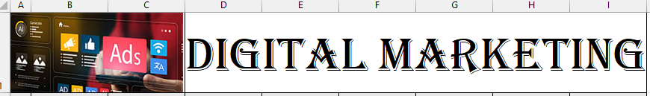 | (3)
 | 3.1.3 | Adjust the column widths and row heights of rows 1 and 2 so that all details are visible. | (2)
 | 3.1.4 | Edit the text in cell F2 to display the same as cells D2 and H2. | (1)
 | 3.1.5 | Assign the number format currency to column I. | (1)
3.2 | The totals under the column ‘Total Income’ are calculated by multiplying the number of clicks with the cost per click.  Enter a formula in cell I5 to calculate the total income for the Advert with ID 3. |  | (3)
3.3 | Enter a function in cell L5 to calculate the average cost per click for all the adverts. Round the result up to one decimal place. |  | (4)
3.4 | An attempt was made in cell L6 to find the campaign type of the advert with the ID 6.  - Modify the function so that the correct campaign type is shown. |  | (3)
Save and close sheet Global Performance.

Work in Sheet 2 sheet.
3.5 | Rename the sheet to ‘Sorting’ and move the worksheet to appear as the last worksheet in the workbook. |  | (2)
3.6 | Assign blue as the sheet tab colour. |  | (1)
3.7 | Sort the sheet first alphabetically according to the industry and then according to the cost per purchase, starting with the lowest number on top. |  | (3)
 |  |  | [24]

QUESTION 4: SPREADSHEETS
_{NOTE:}
- Use formulae and/or functions for ALL calculations in the spreadsheet.
- Use absolute cell references ONLY where it is required by the question to ensure that formulae are correct when you copy it to other cells in the spreadsheet.
- Insert formulae and/or functions in such a manner that the correct results will still be obtained even if the existing data changes.
- Should you need to use building blocks, use the allocated space in the spreadsheet.

Open the 4eCommerce Customers spreadsheet.
Work in the Customers sheet.
4.1 | Convert the dataset into a table with the ‘Dark Teal Medium 2’ table style. | (2)
4.2 | Apply a feature so that the column headings remain visible while scrolling through the worksheet data. | (1)
4.3 | Convert all the values in the Total_Purchases column to the Number format and display the values with one decimal place. | (2)
4.4 | A Customer ID is generated for each customer consisting of the following:  - The first letter of the gender, followed by  - a dash (-),  - the country, and  - the customer’s age.  Eg: M-India34  Insert a function in cell M3 to generate the Customer ID for the customer in row 3. | (7)
4.5 | Insert a function in cell M4 to display the number of characters in the city with the longest name. | (3)
Save your changes and close the 4eCommerce customers spreadsheet.
 |  | [15]

QUESTION 5: DATABASE
Open the 5Campaign Data database.

5.1 | Open the tbl5_1 table in Design View.
 | 5.1.1 | Edit the properties of the CampaignType field so that the text would not exceed 15 characters. | (1)
 | 5.1.2 | Edit the Convert field to an appropriate data type where the user can tick a box. | (1)
 | 5.1.3 | Apply validation to the Gender field to ensure that only the values “Male” or “Female” can be entered. Display an appropriate error message to guide the user if any other value is entered. | (4)
 | 5.1.4 | Assign a setting to the Purchases field so that the value 9 automatically appears for new records. | (1)
 | 5.1.5 | Apply a setting to the Age field to make it a required field, ensuring that the user cannot leave it empty. | (1)
 | 5.1.6 | Apply an input mask to the Income field to ensure that values are entered in a valid currency format (include a currency symbol and correct decimal places). | (3)
 | 5.1.7 | Modify the properties of the CampaignType field so that it displays as shown in the example below.  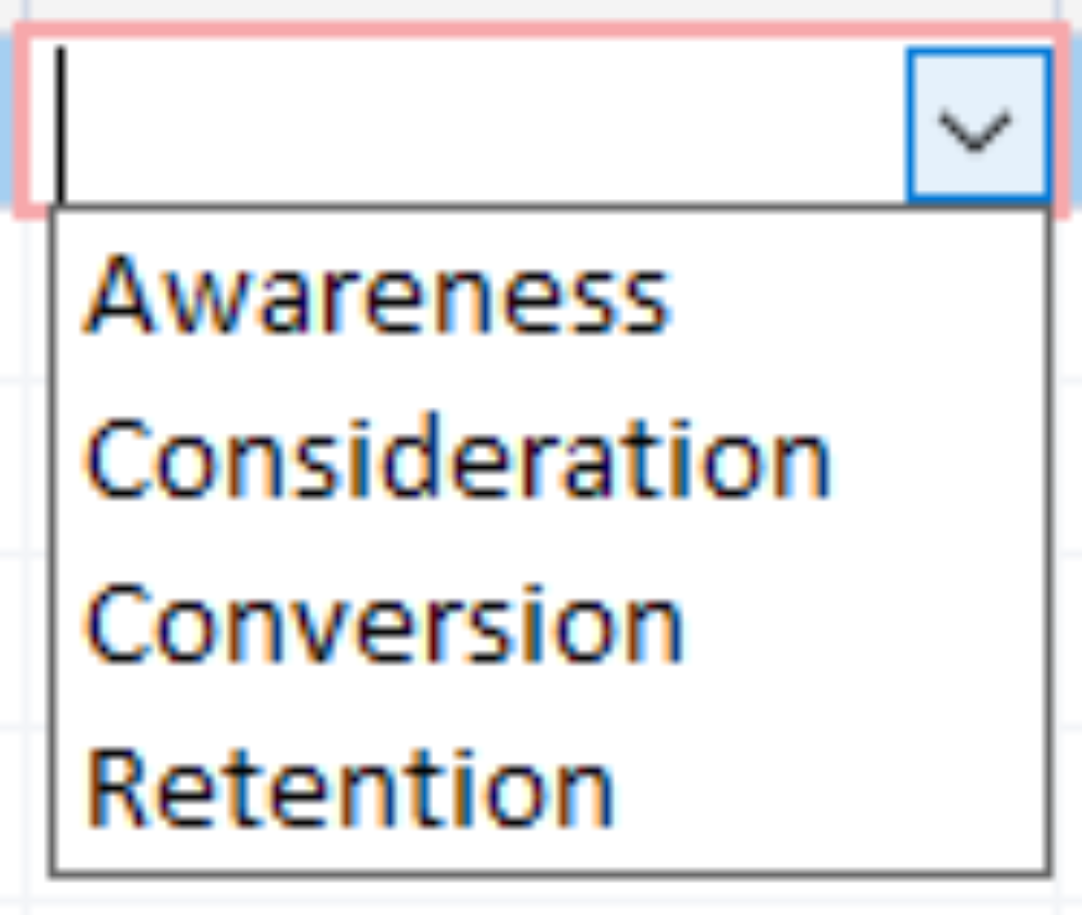 | (3)
Save and close the tbl5_1 table.
5.2 | Open the qry5_2 query, based on the tbl5_1 table, in Design View.  Modify the query to display:  - Female customers with an income of less than R100000.00.  - The fields CustomerID, Age, Gender and Income.  Save and close the qry5_2 query. |  | (3)
5.3 | Create a query called qry5_3 based on the tbl5_1 table to display:  - Customers who are over the age of 40.  - Who made 4 purchases.  - Using the email channel to campaign.  - The fields CustomerID, Age, CampaignChannel and Purchases.  Save and close the qry5_3 query. |  | (5)
5.4 | Create a query called qry5_4 based on the tbl5_1 (Xtra) table as follows:  - Display all customers from USA with no credit balance.  - Show the fields Age, Gender and Country.  Save and close the qry5_4 query. |  | (4)
5.5 | Create a query called qry5_5 based on the tbl5_1 (Xtra) table to display as follow:  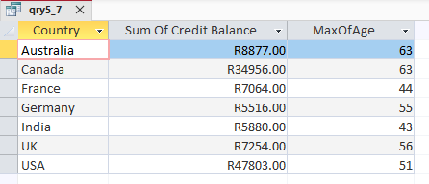  Save and close the qry5_5 query. |  | (4)
5.6 | Create rpt5_6 report, based on the tbl5_1 table as follows:  - Show the fields Age, Gender, Income and CampaignChannel.  - Group the records by CampaignChannel and then Gender.  - Summarise the data by showing the total income per gender.  Save and close the rpt5_6 report. |  | (5)
Save and close the 5Campaign Data database. |  |  | [35]

QUESTION 6: WEB DESIGN (HTML)
NOTE:
- You may NOT use a word processing program such as Word to answer the HTML questions.
- An HTML tag sheet has been attached for reference.
- All files needed to complete this question can be found in the examination folder.

6.1 Open the incomplete 6Index.html web page in a web browser and in a text/HTML editor (NOT a word processing program such as Word).
Your final web page should look like the example below.

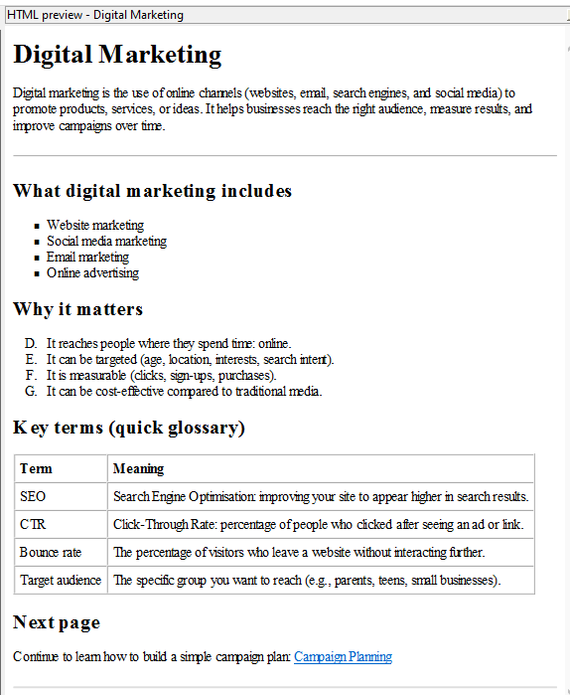

NOTE:
- Use the example on the previous page as a guideline when answering this question.
- Question numbers appear as comments in the coding to indicate where you should insert the answer(s). DO NOT delete these comments.

6.1.1 | Insert your name and surname as a comment in the web page. | (1)
6.1.2 | Edit the code to display the text ‘Essentials of Digital Marketing’ in the web browser tab. | (1)
6.1.3 | Set the page colour to very light grey (#F5F5F5). | (1)
6.1.4 | Change the alignment of the first paragraph to display in the centre of the page. | (1)
6.1.5 | Change the bulleted list below the heading ‘What digital marketing includes’ to display as the screenshot below:  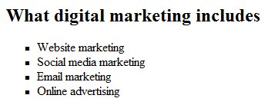 | (2)
6.1.6 | Format the heading 'Why it matters' to display as the third biggest heading. | (1)
6.1.7 | Convert the list that follows to display as:  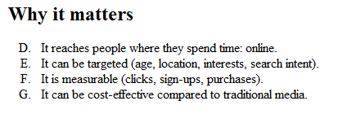 | (2)
6.1.8 | Add a row to the table on the page to display as the screenshot below:  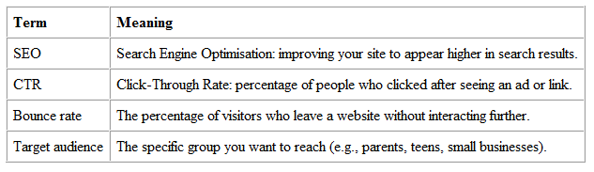 | (3)
6.1.9 | Correct the HTML code at the end of the document so that the hyperlink will move to the indicated web page. | (2)
ONE mark will be allocated for closing tags and correct nesting in both the web pages. |  | (1)
 |  | [15]

QUESTION 7: GENERAL
You are working for a digital marketing company called BrightWave Marketing. The company is launching a new campaign offering digital marketing services to small businesses.

You are required to create a personalised letter using the Mail Merge feature to send to potential clients.

7.1 | Open the 7Marketing Letter word-processing document and make the following changes to the document:
 | 7.1.1 | Insert today’s date using an automatic field at the appropriate place indicated in the document. Make sure that the date display in the format: ‘dddd, dd,mm,yyyy’. | (3)
 | 7.1.2 | Insert the heading: ‘Digital Marketing Solutions for Your Business’ and apply the Heading 2 style to it. | (2)
7.2 | Convert the document into a Mail Merge document.  Use the data source file 7Client List.xlsx.  - Each client receives a personalised message referencing their business.  - Include only clients from Cape Town or Pretoria.  - Include a personalised greeting: Dear <<Client_Name>>.  - Insert the following merge fields appropriately:  - Client Name  - Business Name  - Email  - City  - Add a call-to-action: Contact us today to grow your online presence! |  | (8)
7.3 | Complete the merge and generate:  - Individual letters for the identified clients.  - Save the merged document as 7Merged_Letters.docx. |  | (2)
Save and close the completed 7Merged_Letters document.
 |  |  | [15]
GRAND TOTAL: |  |  | [150]

